Java Questions List

Control Statement-1 (1-29)

|  |
| --- |
|  |
|  |
|  |  | |
| 1) WAP to calculate area of circle. | |
| 2. WAP to calculate area of rectangle | |
| 3. WAP to calculate the percentage of students | |
|  | |
| 4. WAP to exchange value to two variable with third variable and without third variable | |
|  | |
| // Bitwise ^ operator | |
| 5. WAP to exchange value of two variable without using third variable and arithmetic operator | |
|  | |
| 6. WAP to find greater among two number | |
|  | |
| 7. WAP to find greater among three number | |
|  | |
| 8. WAP to check wheather number is even or odd | |
|  | |
| 9. WAP to check wheater number is positive or negative | |
|  | |
| 10. Print number between 1 to 5 in word format | |
|  | |
| 11. Find even odd using switch case | |
|  | |
| 12. Check given character is vowel or not using switch case | |
|  | |
| 13. Program to perform arithmetic operation using switch case | |
|  | |
| 14. WAP to find lowest number among four different number | |
|  | |
|  | |
| 15. WAP to check given year is a leap year or not | |
|  | |
| 16. W.A.P to convert temperature from Fahrenheit to Celsius and Celsius to Fahrenheit. For given problem you have to take choice from user. If user enter choice ‘c’ or ‘C’ then convert Fahrenheit to Celsius. If user enter choice ‘f’ or ‘F’ then convert Celsius to Fahrenheit. | |
|  | |
| 17. W.A.P to check the sign of given number. | |
|  | |
| 18. W.A.P to check whether given number is even or odd Without using % operator. | |
|  | |
| 19. W.A.P to check whether the traingle is equilateral, scalene, or isosceles. Hint: - Isosceles triangle: In geometry, an isosceles triangle is a triangle that has two sides of equal length. Equilateral triangle: In geometry, an equilateral triangle is a triangle in which all three sides are equal. Scalene triangle: A scalene triangle is a triangle that has three unequal sides. | |
|  | |
| 20. W.A.P to check whether a charachter is an alphabet or not. | |
|  | |
| 21. Java program to check whether the triangle is valid or not if angles are given. Hint:- The angle property of the triangle says that the sum of all three angles should be equal to 180. | |
|  | |
| 22. Write a Java program to check whether a number is divisible by 5 and 11 or not. | |
|  | |
| 23. Write a Java program to input day number and print week day. | |
|  | |
| 24. Write a Java program to count total number of notes in given amount. | |
|  | |
| 25. Write a Java program to calculate profit or loss. | |
|  | |
| 26. Write a Java program to input marks of five subjects Physics, Chemistry, Biology, Mathematics and Computer. Calculate percentage and grade according to following: | |
| Percentage >= 90% : Grade A | |
| Percentage >= 80% : Grade B | |
| Percentage >= 70% : Grade C | |
| Percentage >= 60% : Grade D | |
| Percentage >= 40% : Grade E | |
| Percentage < 40% : Grade F | |
|  | |
| 27. Write a Java program to input basic salary of an employee and calculate its Gross salary according to following: Basic Salary <= 10000 : HRA = 20%, DA = 80% | |
| Basic Salary <= 20000 : HRA = 25%, DA = 90% | |
| Basic Salary > 20000 : HRA = 30%, DA = 95% | |
|  | |
| 28. Write a C program to input electricity unit charges and calculate total electricity bill according to the given condition: For first 50 units Rs. 0.50/unit For next 100 units Rs. 0.75/unit For next 100 units Rs. 1.20/unit For unit above 250 Rs. 1.50/unit An additional surcharge of 20% is added to the bill. | |
|  | |
| 29. Write a program to input choice from user. If user enter ‘+’ as choice then calculate addition of 2 number. If Choice ‘>’ then check which number is greaterst. If choice is ‘==’ then check both number is equal or not. | |
|  |  | |

Control Statement-2 (1-15)

|  |
| --- |
|  |
|  |  | |
| 1. Take values of length and breadth of a rectangle from user and check if it is square or not. | |
| 2.A shop will give discount of 10% if the cost of purchased quantity is more than 1000. | |
| Ask user for quantity | |
| Suppose, one unit will cost 100. | |
| Judge and print total cost for user. | |
|  | |
| 3.A company decided to give bonus of 5% to employee if his/her year of service is more than 5 years. | |
| Ask user for their salary and year of service and print the net bonus amount. | |
|  | |
| 4.A school has following rules for grading system: | |
| a. Below 25 - F | |
| b. 25 to 45 - E | |
| c. 45 to 50 - D | |
| d. 50 to 60 - C | |
| e. 60 to 80 - B | |
| f. Above 80 - A | |
| Ask user to enter marks and print the corresponding grade. | |
|  | |
| 5.Take input of age of 3 people by user and determine oldest and youngest among them. | |
|  | |
| 6. Write a program to print absolute vlaue of a number entered by user. E.g.- | |
| INPUT: 1 OUTPUT: 1 | |
| INPUT: -1 OUTPUT: 1 | |
|  | |
| 7. A student will not be allowed to sit in exam if his/her attendence is less than 75%. | |
| Take following input from user | |
| Number of classes held | |
| Number of classes attended. | |
| And print | |
| percentage of class attended | |
| Is student is allowed to sit in exam or not. | |
|  | |
| 8. Modify the above question to allow student to sit if he/she has medical cause. Ask user if he/she has medical cause or not ( 'Y' or 'N' ) and print accordingly. | |
|  | |
| 9. Write a program to check whether a entered character is lowercase ( a to z ) or uppercase ( A to Z ). | |
|  | |
| 10.Write a program to check if a year is leap year or not. | |
| If a year is divisible by 4 then it is leap year but if the year is century year like 2000, 1900, 2100 then it must be divisible by 400. | |
|  | |
| 11. Ask user to enter age, sex ( M or F ), marital status ( Y or N ) and then using following rules print their place of service. | |
| if employee is female, then she will work only in urban areas. | |
| if employee is a male and age is in between 20 to 40 then he may work in anywhere | |
| if employee is male and age is in between 40 t0 60 then he will work in urban areas only. | |
| And any other input of age should print "ERROR". | |
|  | |
| 12.A 4 digit number is entered through keyboard. Write a program to print a new number with digits reversed as of orignal one. E.g.- | |
| INPUT : 1234 OUTPUT : 4321 | |
| INPUT : 5982 OUTPUT : 2895 | |
|  | |
| 13. Write a Java program that keeps a number from the user and generates an integer between 1 and 7 and displays the name of the weekday. | |
| Test Data | |
| Input number: 3 | |
| Expected Output : | |
| Wednesday | |
|  | |
| 14.Write a program to accept percantage from the user and | |
| display grade according to the following criteria | |
| Marks Grade | |
| > 90 A | |
| >80 and <=90 B | |
| >=60 and <=80 C | |
| below 60 D | |
|  | |
| 15. Write a java program to accept the cost price of a bike | |
| and display the road tax to be paid according to the | |
| following criteria. | |
| Cost Price(In Rs) Tax | |
| > 100000 15% | |
| >50000 and <=100000 10% | |
| <=50000 5% | |

Make A Software by Using if-else/switch without using loop

|  |
| --- |
|  |
| A person enter in a D-Mart mall for the shopping. He is first |
| time visiting the D-mart mall. |
| He/She has to purchase 10 items. |
|  |
| System should ask for the name of the customer and Gender. |
|  |
| User will tell you the item name and quantity of each product |
| purchased one by one. |
|  |
| You have to calculate the total bill amount on the following |
| Criteria basis |
|  |
| on first product purchase if quantitiy greater then |
| 4 then you have to offer 5% discount on total price of that product |
|  |
| on 5th product purchase you have to offer 10% discount on total |
| price. |
|  |
| on 10th product purchase you have to offer 15% discount on total |
| price of that product. |
|  |
| let suppose the cost of 1st product is 10 |
| cost of 2nd product is 20 |
| . |
| . |
| cost of 10th product is 100; |
|  |
| if Total Bill amount is greater then 10000 then you have |
| to offer 15% of total bill amount |
| if total Bill amount is between 5000 and 10000 then |
| you have to offer 10% of total bill amount |
|  |
| Also 10% GST of total Bill Amount |
|  |
| Then you have to ask for carry bag to customer |
| if he/she yes then add 10 rupees in total bill amount. |
|  |
| if the customer is female then you have to gift a Cadeberry |
| If the customer is mael then you have to gift a Ladger Wallet |
|  |
| Develop a Java Application to Generate the Bill in |
| Following Format |
| **Result** |
| D-Mart |
| Name : Cheeku Sing Data: 12/9/2022 |
| ----------------------------------------------------------- |
| Item Name Quantity Price Total After-Discount |
| Item-1 5 10 50 Rs 47.5 Rs |
| Item-2 3 20 60 RS 60.0 RS |
| . |
| . |
| . |
| . |
| . |
| . |
| . |
| Item-10 20 100 2000 300.0 Rs |
| ---------------------------------------------------------- |
| A.P D.P |
| 45000 43500 |
| Gift :- Cadeberry 0.00 0.00 |
|  |
| Carry Bag : yes 10:00 10:00 |
| GST (10%) 450 450 |
| --------------------------------------------------------- |
| 45460 43960 RS |
|  |
| Thank You |
| To Vist |
| D-Mart |
|  |
| ---------------------------------------------------------- |

Loop Questions-1 (1-15)

|  |
| --- |
|  |
|  |  | |
| 1. Program to print 10 times hello on output screen using loop | |
| 2 Program to print 1 to 10 number using loop | |
|  | |
| 3 Program to print 10 to 1 number using loop | |
|  | |
| 4. WAP to print the series 1 2 3 4 5 ...................n | |
|  | |
| 5 WAP to print the series 1 3 5 7 9....................n terms | |
|  | |
| 6 WAP to print the series 2 4 6 8 10..................n terms | |
|  | |
| 7 WAP to print the series 1 4 9 16 25................n terms | |
|  | |
| 8 WAP to print the fibonacci series 0 1 1 2 3 5 8 13..........................n terms | |
|  | |
| 9 WAP to calculate the sum of given series 1 2 3 4 5 6 7 ................n terms | |
|  | |
| 10 WAP to calculate the sum of given series 2 4 6 8 10.....................n terms | |
|  | |
| 11 WAP to calculate the sum of given series 1 - 2 + 3 - 4 + 5 - 6................n terms | |
|  | |
| 12 WAP to program to calculate the factorial of any given number. | |
|  | |
| 13 WAP to calculate the reverse of any given number | |
|  | |
| 14 WAP to input a number and check it palindrome or not | |
|  | |
| 15 WAP to to input 3 digit number and check it is armstron or not | |

Loop Questions-2 (1-10)

|  |
| --- |
|  |
| 1. WAP to enter an integer number and check it is prime or not |
| 2. WAP to calculate x^y (x to the power y) |
| 3. WAP to calculate the sum of given series x^1 + x^2 + x ^3.........x^n |
| 4. WAP to calculate the sum of series 1/1! + 2/2! + 3/3!.......n\n! |
| 5. WAP to print all prime number from 101 to 199 |
| 6. WAP to print the reverse of all number from 101 to 199 |
| 7. WAP to print all palindrome number from 101 to 199 |
| 8. WAP to print all armstrong number from 101 to 999 |
| 9. WAP in C to display the n terms of harmonic series and |
| their sum |
| 1 + 1/2 + 1/3 + 1/4 + 1/5 ... 1/n terms |
| 10. Calculate the sum of following serires |
| 1/x + 1/x^2 + 1/x^3......1/x^n |

Loop * Patterns-1 (1-25)

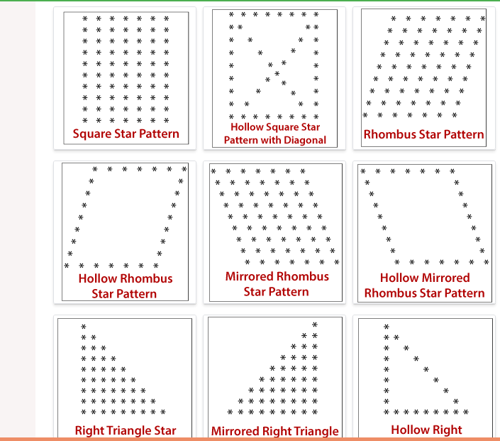

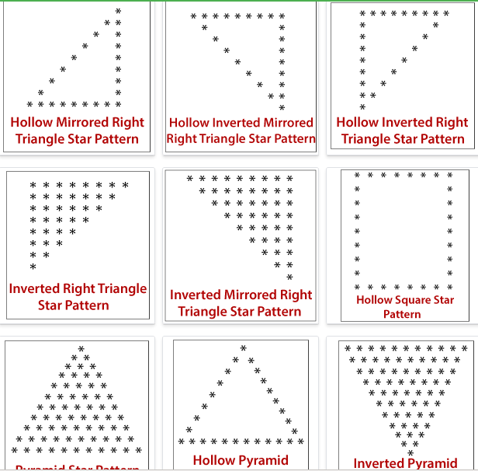

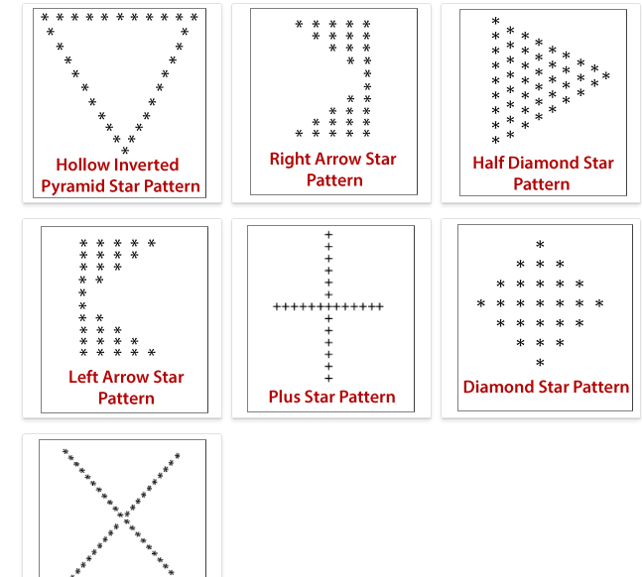

Loop Number Patterns-1 (1-23)

|  |  |  |
| --- | --- | --- |
| 1) 1  1 2  1 2 3  1 2 3 4  1 2 3 4 5 | 2) 1 2 3 4 5  1 2 3 4  1 2 3  1 2  1 | 3) 1  1 2  1 3  1 4  1 2 3 4 5 |
| 4)    1  2 3 2  3 4 5 4 3  4 5 6 7 6 5 4  5 6 7 8 9 8 7 6 5 | 5)  1  1 2  1 3  1 4  1 2 3 4 5 | 6)    1 2 3 4 5  2 5  3 5  4 5  5 |
| 7)    1  121  12321  1234321  123454321 | 8)    A  ABA  ABCBA  ABCDCBA  ABCDEDCBA | 9)  1  1 2 1  1 2 3 2 1  1 2 3 4 3 2 1  1 2 3 4 5 4 3 2 1 |
| 10)  ********1********  *******2*2*******  ******3*3*3*****  *****4*4*4*4****  ****5*5*5*5*5*** | 11)    3  44  555  6666  555  44  3 | 12)  1  2*2  3*3*3  4*4*4*4  4*4*4*4  3*3*3  2*2  1 |
| 13)  1  2*3  4*5*6  7*8*9*10  7*8*9*10  4*5*6  2*3  1 | 14)    *  **\* 1 \***  **\* 1 2 1 \***  **\* 1 2 3 2 1 \***  **\* 1 2 1 \***  **\* 1 \***  **\*** | **15)**  1  0 1  1 0 1  0 1 0 1  1 0 1 0 1  0 1 0 1 0 1  1 0 1 0 1 0 1  0 1 0 1 0 1 0 1 |
| **16)**  2  3 5  7 11 13  17 19 23 29  31 37 41 43 47 | **17)**  10101  01010  10101  01010  10101 | **18)**  10001  01010  00100  01010  **10001** |
| **19.**  1  11  121  1221  **12221** | 20.  1  121  12321  1234321  123454321 | 21.    * * * * * * * * *  * * * * * * * *  * * * * * *  * * * *  * * |
| 22.    * *  * * * *  * * * * * *  * * * * * * * *  * * * * * * * * * * | 23.      *  * *  * * *  * * * *  * * * * *  * * * *  * * *  * *  * |  |
|  |  |  |